Basics Of Multithreading

//Q1 Write a program to demonstrate the use of volatile keyword.
import java.util.Scanner;
class Ques1 extends Thread {
private boolean running = true;
public void run() {
while(running) {
System.out.println("Running.....");
try {
Thread.sleep(500);
} catch (InterruptedException e) {
e.printStackTrace();
}
}
}
public void exit() {
running = false;
}
}
class Main {
public static void main(String[] args) {
Ques1 q1 = new Ques1();
System.out.println("Press enter to stop the execution .");
q1.start();
Scanner sc=new Scanner(System.in);
sc.nextLine();
q1.exit();
}
}

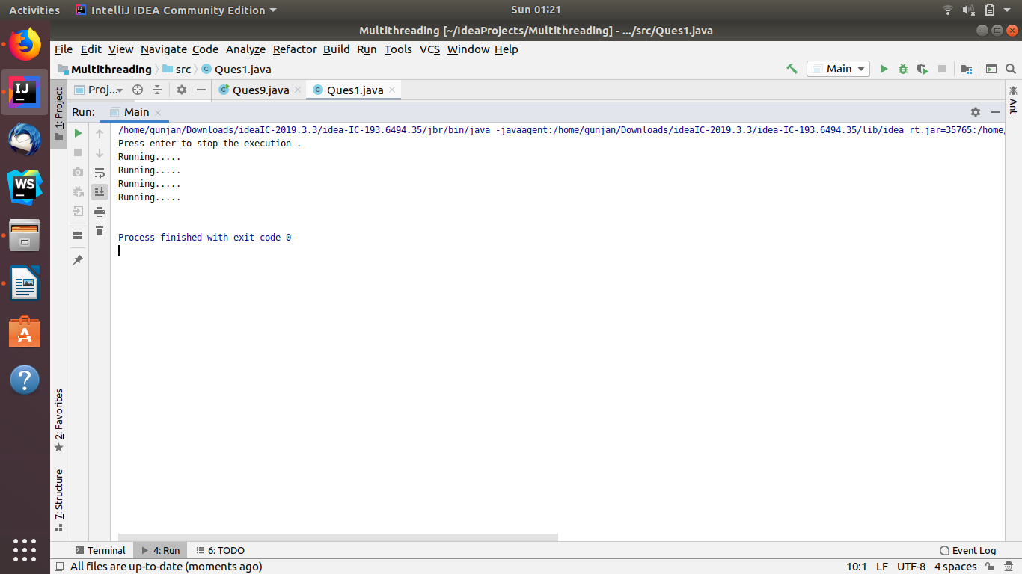

//Q2 Write a program to create a thread using Thread class and Runnable interface each.
package Ques2;
class Runner_Q2 extends Thread {
@Override
public void run() {
System.out.println("Starting thread by extending Thread class... ");
try {
Thread.sleep(1000);
} catch (InterruptedException e) {
e.printStackTrace();
}
}
}
class Main {
public static void main(String[] args) {
Runner_Q2 runner1 = new Runner_Q2();
runner1.start();
// Runner_Q2 runner2 = new Runner_Q2();
// runner2.start();
Runner1_Q2 q=new Runner1_Q2();
Thread t1 = new Thread(q);
t1.start();
}
}
package Ques2;
public class Runner1_Q2 implements Runnable {
@Override
public void run() {
System.out.println("Starting Thread by implementing Runnable Interface.... ");
try {
Thread.sleep(100);
} catch (InterruptedException e) {
e.printStackTrace();
}
}
}

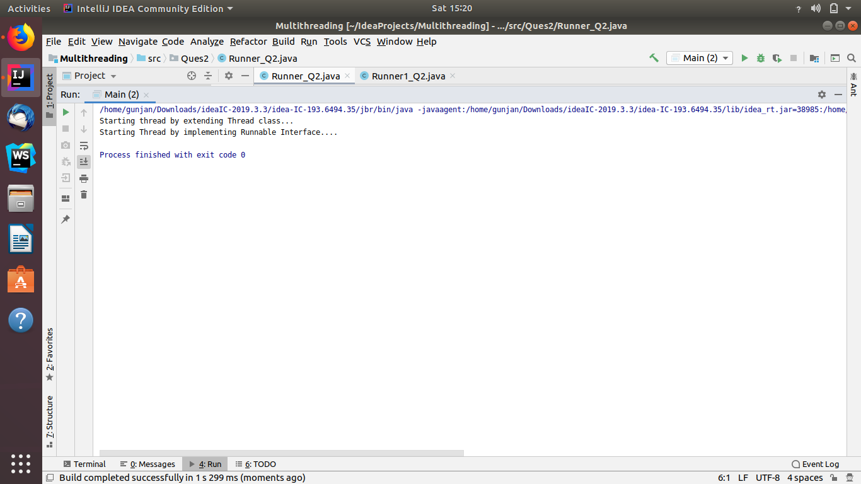

//Q3 Write a program using synchronization block and synchronization method
//Using Method synchronization
package Ques3;
public class q3 extends Thread {
@Override
public synchronized void run() {
for (int i=0;i<3;i++)
{
System.out.println("Thread: "+i);
}
System.out.println();
}
public static void main(String[] args) {
q3 q = new q3();
Thread t1=new Thread(q);
Thread t2=new Thread(q);
t1.start();
t2.start();
}
}
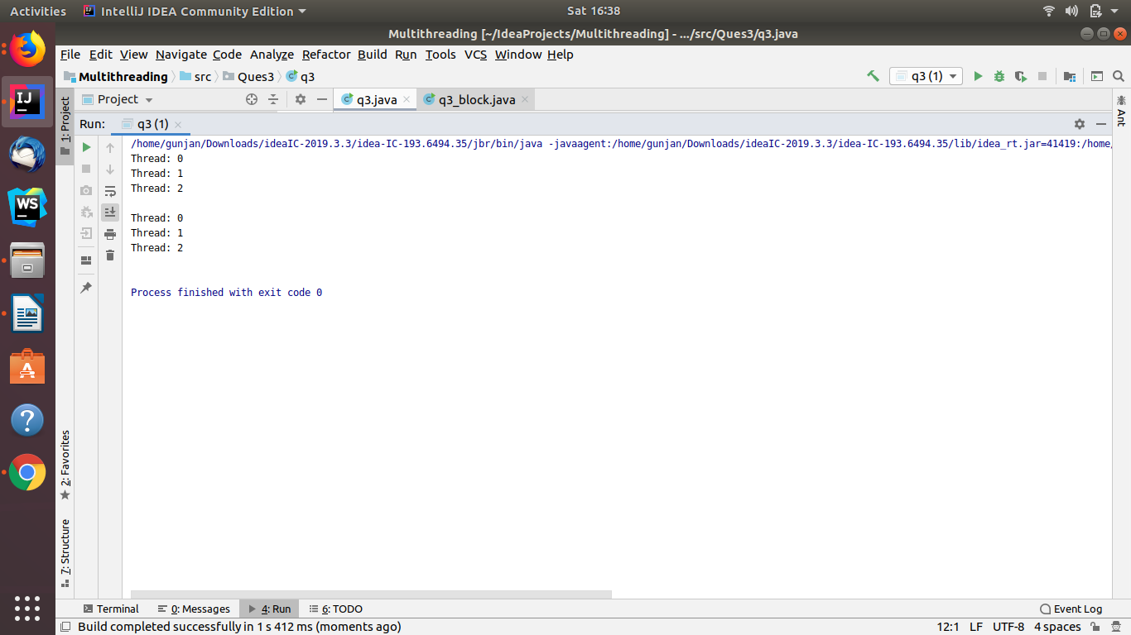

//Using synchronization Block
package Ques3;
public class q3_block extends Thread {
@Override
public void run() {
synchronized (this) {
for (int i = 0; i < 5; i++) {
System.out.println("* " + i + " *");
}
}
System.out.println();
}
public static void main(String[] args) {
q3_block q = new q3_block();
Thread t1=new Thread(q);
Thread t2=new Thread(q);
t1.start();
t2.start();
}
}
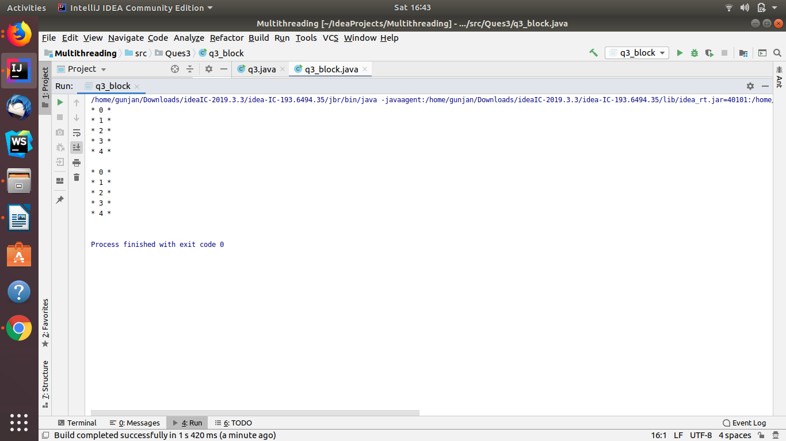

//Q4 Write a program to create a Thread pool of 2 threads where one Thread will print even numbers and other will print odd numbers.
import java.util.concurrent.ExecutorService;
import java.util.concurrent.Executors;
public class Ques4 {
static class even implements Runnable{
@Override
public void run() {
System.out.println("Thread Printing even numbers: ");
for (int i = 0; i < 10; i = i + 2) {
System.out.println(i);
}
}
}
static class odd implements Runnable{
@Override
public void run() {
System.out.println("Thread printing odd numbers: ");
for (int i = 1; i < 10; i = i + 2) {
System.out.println(i);
}
}
}
public static void main(String[] args) {
ExecutorService pool= Executors.newFixedThreadPool(2);
//Creating two tasks:
Runnable evenR=new even();
Runnable oddR=new odd();
//passing the task objects to the pool to execute
pool.execute(evenR);
pool.execute(oddR);
pool.shutdown();
}
}
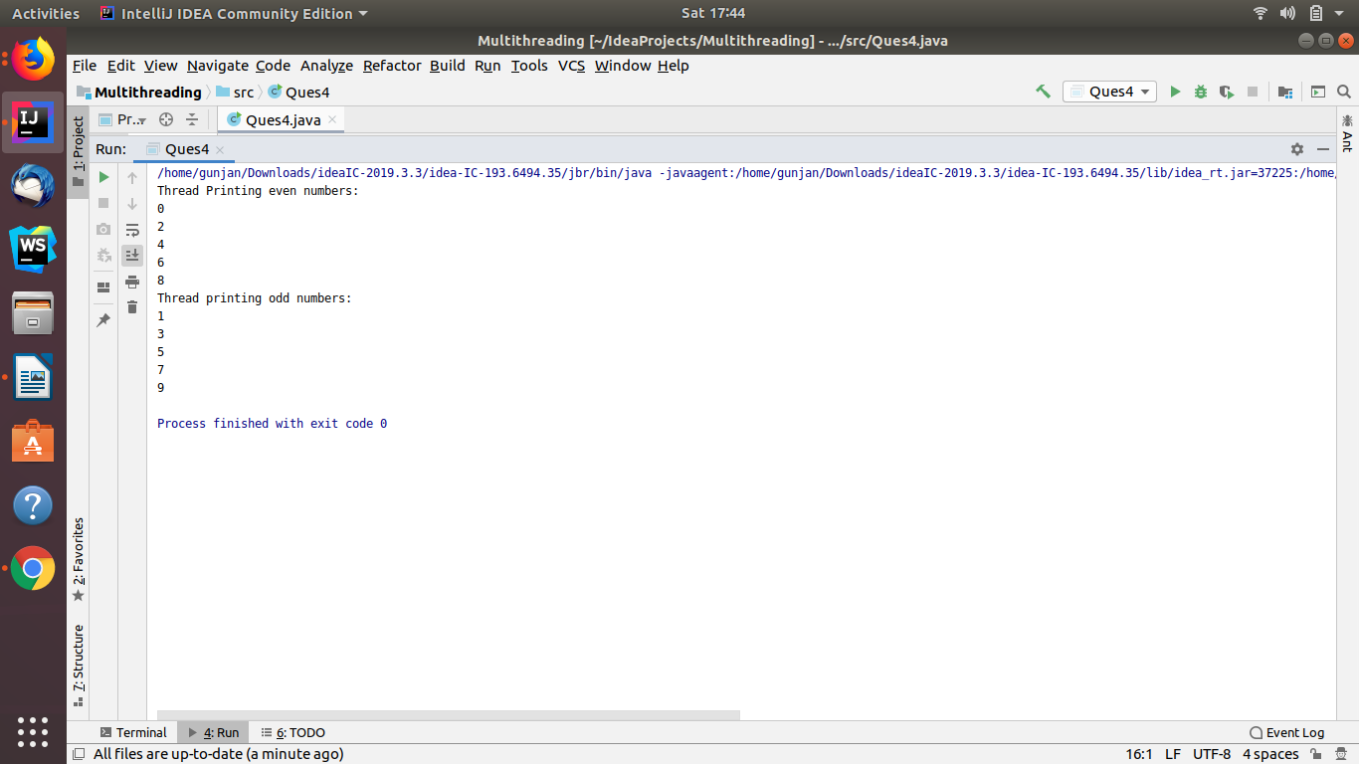

//Q5 Write a program to demonstrate wait and notify methods.
import java.util.Scanner;
public class Ques5 {
public static void main(String[] args) throws InterruptedException {
Processor processor=new Processor();
Thread t1 = new Thread(new Runnable() {
public void run() {
try {
processor.producer();
} catch (InterruptedException e) {
e.printStackTrace();
}
}
});
Thread t2 = new Thread(new Runnable() {
public void run() {
try {
processor.consumer();
} catch (InterruptedException e) {
e.printStackTrace();
}
}
});
t1.start();
t2.start();
t1.join();
t2.join();
}
}
class Processor {
public void producer() throws InterruptedException {
synchronized (this) {
System.out.println("Producer thread is running ....");
wait();
System.out.println("producer-Resumed ");
}
}
public void consumer() throws InterruptedException {
Scanner scanner = new Scanner(System.in);
Thread.sleep(200);
synchronized (this) {
System.out.println("Producer thread is waiting and consumer thread started its execution..");
System.out.println("Waiting for return key.(press any key) to stop consumer thread");
scanner.nextLine();
System.out.println("Return key pressed. and producer thread started its execution again");
notify();
Thread.sleep(500);
}
}
}
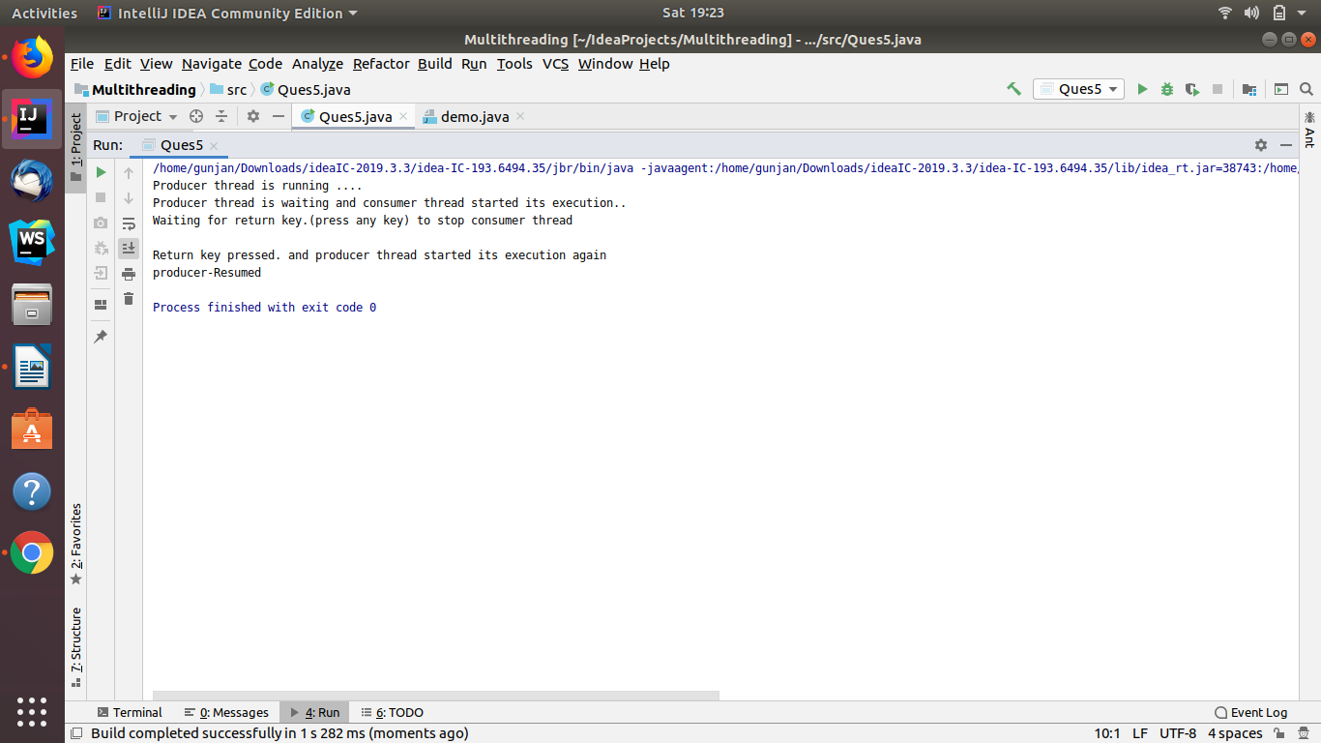

//Ques6 Write a program to demonstrate sleep and join methods.
public class Ques6 implements Runnable
{
//Thread t;
public void run()
{
for (int i = 0; i < 4; i++)
{
System.out.println(Thread.currentThread().getName()+ " : " + i);
try
{
Thread.sleep(1000);
}
catch (Exception e)
{
System.out.println(e);
}
}
}
public static void main(String[] args) throws Exception {
Thread t = new Thread(new Ques6());
t.start();
t.join();
System.out.println();
Thread t2 = new Thread(new Ques6());
t2.start();
}
}

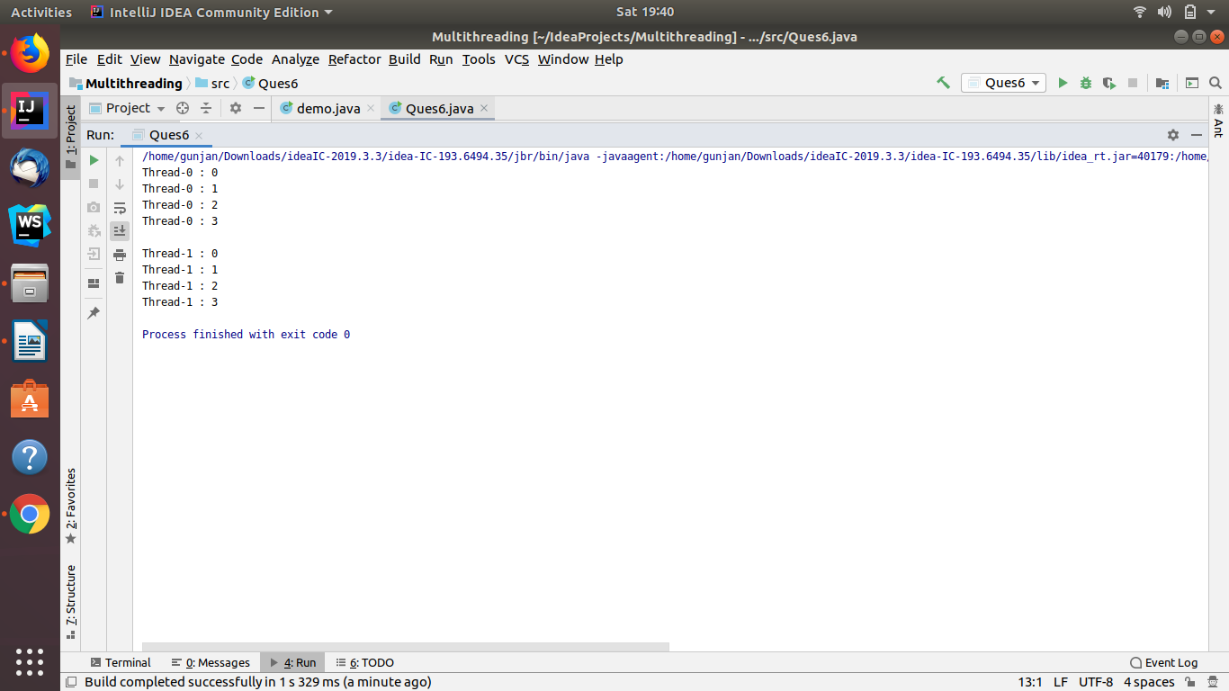

//Q7 Run a task with the help of callable and store it's result in the Future.
import java.util.concurrent.*;
public class Ques7 {
public static void main(String[] args) {
ExecutorService executorService= Executors.newCachedThreadPool();
Future<Integer> future=executorService.submit(new Callable<Integer>() {
@Override
public Integer call() throws Exception {
int sum = 0;
for (int i = 1; i <= 5; i++) {
sum += i;
}
return sum;
}
});
executorService.shutdown();
try{
System.out.println("Final result of Addition of first 5 Integers is : "+future.get());
} catch (InterruptedException | ExecutionException e) {
e.printStackTrace();
}
}
}
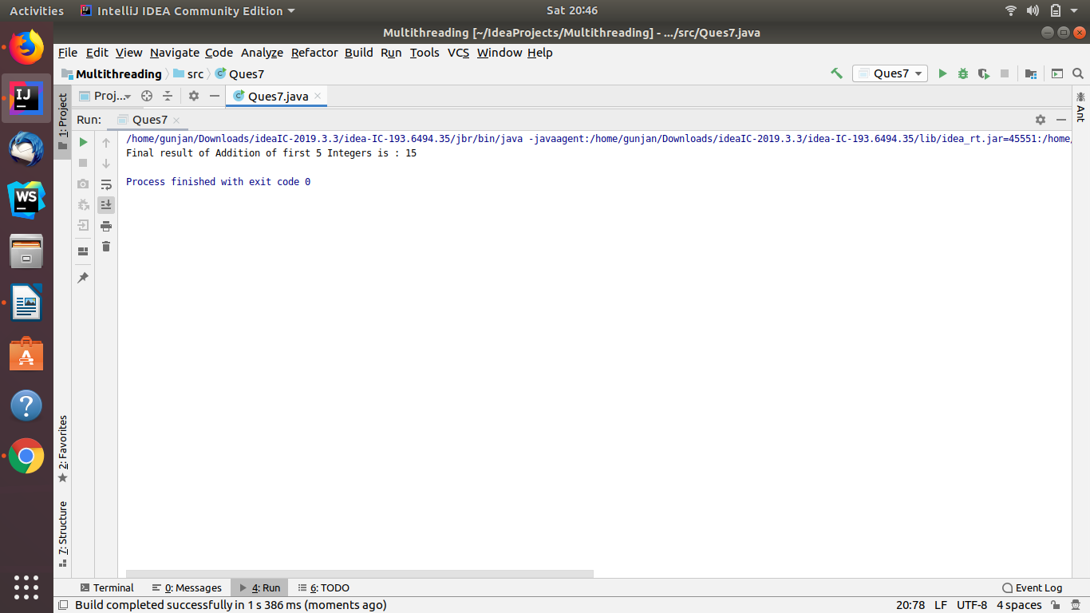

//Q8 Write a program to demonstrate the use of semaphore

import java.util.concurrent.Semaphore;
public class Ques8 extends Thread {
private static String str;
public static void main(String[] args) throws InterruptedException {
str="Gunjan Dawar";
Semaphore s = new Semaphore(1);
Thread t1 = new Thread(new Runnable() {
@Override
public void run() {
try {
s.acquire();
System.out.println("Available Permits: "+s.availablePermits());
System.out.println(Thread.currentThread().getName()+ " aquires lock");
Thread.sleep(1000);
str = "Hi,How are you ?";
System.out.println(str);
} catch (InterruptedException e) {
e.printStackTrace();
}
System.out.print(Thread.currentThread().getName() + " releases the acquired semaphore.\n");
s.release();
System.out.println("Available Permits: "+s.availablePermits());
System.out.println();
}
});
Thread t2 = new Thread(new Runnable() {
@Override
public void run() {
try {
s.acquire();
System.out.println("Available Permits: "+s.availablePermits());
System.out.println(Thread.currentThread().getName()+ " aquires lock");
Thread.sleep(1000);
str = "I am good..";
System.out.println(str);
} catch (InterruptedException e) {
e.printStackTrace();
}
System.out.print(Thread.currentThread().getName() + " releases the acquired semaphore.\n");
s.release();
System.out.println("Available Permits: "+s.availablePermits());
System.out.println();
}
});
t1.start();
t2.start();
}
}

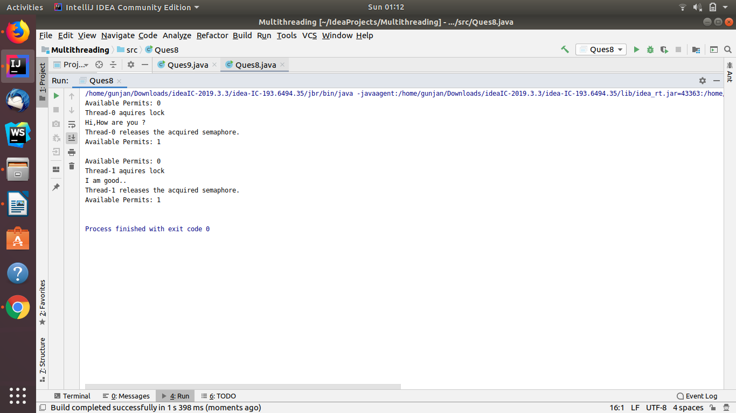

//Q9 Write a program to demonstrate the use of CountDownLatch
import java.util.concurrent.CountDownLatch;
public class Ques9 extends Thread{
CountDownLatch count;
Ques9(CountDownLatch count){
this.count=count;
}
@Override
public void run(){
System.out.println("Starting...");
try {
Thread.sleep(500);
}
catch (InterruptedException e) {
e.printStackTrace();
}
count.countDown();
}
public static void main(String[] args) throws InterruptedException {
CountDownLatch count = new CountDownLatch(2);
Ques9 ques9=new Ques9(count);
Thread t1=new Thread(ques9);
Thread t2=new Thread(ques9);
t1.start();
t2.start();
count.await();
}
}
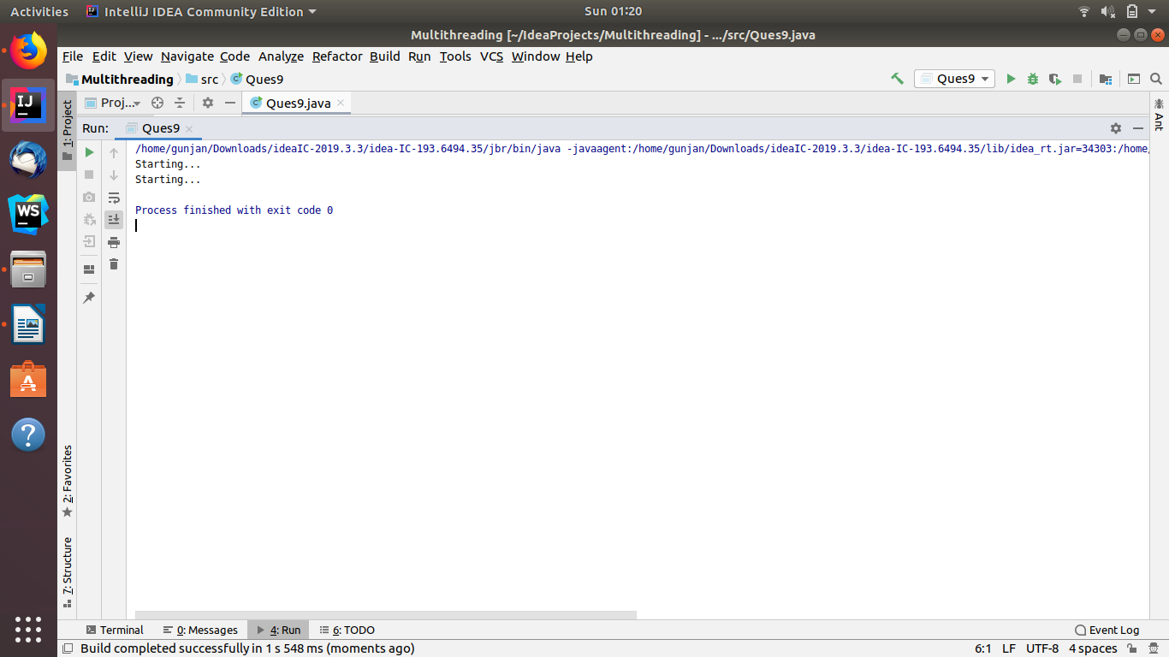

//Q10 Write a program which creates deadlock between 2 threads
public class Ques10 extends Thread{
public static void main(String[] args) {
final String resource1 = "Gunjan";
final String resource2 = "Dawar";
Thread t1 = new Thread() {
public void run() {
synchronized (resource1) {
System.out.println("Thread 1: locked resource 1");
try { Thread.sleep(100);} catch (Exception e) {}
synchronized (resource2) {
System.out.println("Thread 1: locked resource 2");
}
}
}
};

Thread t2 = new Thread() {
public void run() {
synchronized (resource2) {
System.out.println("Thread 2: locked resource 2");
try { Thread.sleep(100);} catch (Exception e) {}
synchronized (resource1) {
System.out.println("Thread 2: locked resource 1");
}
}
}
};

t1.start();
t2.start();
}
}
